Choose and Book Referral Status:
Interaction Model
Amendment History:
Version | Date | Amendment History
0.1 | 12/01/2006 | First draft for comment
0.2 | 16/01/2006 | Feedback from Ross Dixon on initial interaction.
0.3 | 16/01/2006 | Feedback from Nancy Pickering on version 0.2.
0.4 | 20/01/2006 | Output of analysis review meeting on 17/1/2006.
0.5 | 23/01/2006 | Further review comments from Nancy Pickering.
0.6 | 27/01/2006 | Changes to sequence diagrams to following development of interaction units.
1.0 | 07/02/2006 | Approved version
Forecast Changes:
Anticipated Change | When
Reviewers:
This document must be reviewed by the following. Indicate any delegation for sign off.
Name | Signature | Title / Responsibility | Date | Version
Paul Stitt |  | Technical Architect, Choose and Book
Simon Withey |  | Head of Business Requirements & Implementation Support
Nancy Pickering |  | Business Analyst , Business Requirements Team

Approvals:
This document requires the following approvals:
Name | Signature | Title / Responsibility | Date | Version
Chris Elkins |  | Future Development Manager, Choose and Book
Ross Dixon |  | Senior Business Architect, Business Requirements Team
Distribution:
Reviewers and Approvers.
Document Status:
This is a controlled document.
Whilst this document may be printed, the electronic version maintained in FileCM is the controlled copy. Any printed copies of the document are not controlled.
Related Documents:
These documents will provide additional information.
Ref no | Doc Reference Number | Title | Version
1 | NPFIT-SHR-QMS-PRP-0015 | Glossary of Terms Consolidated.doc | 11
2 | NPFIT-SHR-MODL-GUID-0001 | Process Modelling Authoring Guide | 04
3 | NPFIT-ELIBR-AREL-P1R2-0121 | Message Implementation Manual | 01
4 | NPFIT-SHR-MODL-GUID-0004 | Process Modelling User Guide | 02
5 | NPFIT-EBS-DES-0015.05 | Choose and Book Service Manual | 05
6 | NPFIT-NCR-2006b-REQ-0013 | Volumetric Requirements 2006-B Issue 1 Draft D | 01
7 | NPFIT-EBS-DES-0036 | Choose and Book Compliance V5.0 | 03
8 | NPFIT-SHR-MODL-GUID-0008 | Communications Requirements Design Guide | 01
9 | NPFIT-SHR-MODL-CHB—0001 | Choose and Book Referral Status Scope Document | 01
10 | NPFIT-SHR-MODL-CHB-0002 | Choose and Book Referral Status Model (Native) | 01
11 | NPFIT-SHR-MODL-CHB-0003 | Choose and Book Referral Status Model (HTML) | 01
12 | NPFIT-FNT-TO-DQN-0102 | Advice on handling ‘Flagged’ records on PDS | 01
13 | NPFIT-EBS-DES-0075 | Choose and Book Referral Message Guidance | 05
14 | NPFIT-SHR-MODL-CHB—0004 | Choose and Book Referral Status (Supporting Documents) | 02
Glossary of Terms:
List any new terms created in this document. Mail the NPO Quality Manager to have these included in the master glossary above [1].
Term | Acronym | Definition

Contents
1 About this Document 5
1.1 Purpose 5
1.2 Audience 5
1.3 Content 5
1.4 Terminology 5
1.5 Issues 5
2 Choose and Book Referral Status 6
2.1 Overview 6
2.2 Interactions 7
2.2.1 Interaction: Retrieve Outline Referral Information 7
2.2.2 Interaction: Retrieve Outline Referral Information (Error Flow) 11
2.2.3 Interaction: Retrieve Details of Specific Referral 15
2.2.4 Interaction: Retrieve Detail Referral Information (Error Flow) 19

About this Document

Purpose
The purpose of this document is to further elaborate on the functionality described in [9] using a series of interaction diagrams and associated descriptions. This functionality has already been described by use cases in [14]. The interaction diagrams reference these use cases. Specifically these are the interactions required to allow an external application to obtain information from Choose and Book about a particular patient’s referrals and requests for advice and guidance.

Audience
The primary audience of this document are the team who generate message designs. Detailed knowledge of Choose and Book is therefore not assumed.

Content
This document comprises
- Interaction diagrams for each of the interactions.
- Interaction descriptions for each of the interaction diagrams.

Terminology
For simplicity in this document, both referrals and requests for advice and guidance are referred to as referrals.
All requests to retrieve information from Choose and Book will require the user of the calling application to be uniquely identifiable and validated by Choose and Book. In the case of professional users, it is assumed the role profile code (RPC) will be passed to Choose and Book to allow this happen. In the case of patient users, it is assumed that the patient’s NHS number will be provided. For simplicity in this document, this ID is referred to as ‘the unique identifier of the enquirer’, without specifying what this is.
For consistency with the Use Case Model [9], the user of the Client System is referred to as the Enquirer. The Enquirer may be either a patient or a professional user of Choose and Book.

Issues
- None.

Choose and Book Referral Status

Overview
Three types of system have initially been identified which may require an interface to Choose and Book in order to investigate the status of a patient’s referrals. These are the GP systems used in primary care, the Patient Administration systems used in secondary care and Healthspace, the patient self-care system. However, other systems in future may also make use of the interface and thus the identity of the calling application and its functionality has been kept generic and described only at a high level.
Two scenarios are initially envisaged:
- A user of the calling application wishes to view outline information about the patient’s referrals held in Choose and Book. The calling application communicates with Choose and Book in order to retrieve this information.
- A user of the calling application wishes to view the details of a particular referral held in Choose and Book. The calling application communicates with Choose and Book in order to retrieve this information.
It is not assumed that the calling application will perform the first scenario as a prerequisite to the second scenario; these are regarded as independent processes as far as Choose and Book is concerned. It is possible that some (or all) of the calling applications will retrieve the UBRN of the referral whose detail is sought from Choose and Book first.
It is, however, assumed that any calling application will be PDS compliant and thus the patient’s NHS number will be validated in PDS before any request is made of Choose and Book.
A number of factors influence what information the enquirer may retrieve from Choose and Book. This is detailed in the use cases of [14]. Choose and Book will always validate the request for completeness.
Note that only a certain amount of historical data is held in Choose and Book and it will only be possible to retrieve details of those referrals currently held in the system at the time of the enquiry. An attempt to retrieve details of a referral which has been archived will result in an error. This error will be different from the error which would result in a request to view details of a referral using a UBRN which has never existed in Choose and Book.

Interactions

Interaction: Retrieve Outline Referral Information

Interaction Name | Retrieve Outline Referral Information
Identifier | CABID1
Controlling Use Case | Retrieve Outline Referral Information (CAB5)
Summary Description:
An NHS number is supplied by the calling application, along with a code uniquely identifying the enquirer. In response, a list of the referrals held in Choose and Book for that patient will be returned (noting there may be none or none that the enquirer is allowed to see).
In addition to the unique identifier for each referral (the unique booking reference number or UBRN) outline information about each referral will be supplied.
Preconditions | Enquirer has already searched for and uniquely identified the patient on PDS.  Patient has an NHS number.
Triggering Event | Enquirer performs an action in the client system that triggers the client system to request outline referral information for a patient from Choose and Book.
Triggering Event Type | Interaction
Subject Class | N/A
Interaction Unit(s) involved | - Request outline information on all referrals for the patient  - Respond with outline information on referrals the enquirer is authorised to see
Sequence Diagram | See Figure 1.
Interaction Description:
Enquirer
- Decides to review referrals for patient and Initiates interaction with client system.
- Review referral information.
Client System (Host System Role)
- Receive request from enquirer and determine that this needs to be passed externally.
- Format information for display to enquirer.
Choose and Book Outline Referral Request Placer (Application Role)
- Receive request from Client system for referral information. Format and send request for this information to Choose and Book Outline Referral Request Fulfiller.
- Receive referral information from Choose and Book Outline Referral Request Fulfiller.
Choose and Book Outline Referral Request Fulfiller (Application Role)
- Receive request from Choose and Book Outline Referral Request Fulfiller and forward this to Choose and Book.
- Format referral information received into appropriate communication back to Choose and Book Outline Referral Request Placer.
Choose and Book (Host System Role)
- Receive request from Choose and Book Outline Referral Request Fulfiller for patient referral information. Determines if enquirer is entitled to see this information and what information can be displayed to the enquirer.
- Collate information to be returned and send to Choose and Book Outline Referral Request Fulfiller.
Notes:
- This is a synchronous interaction.
- The processing described in the Choose and Book (Host System Role) will involve interactions with PDS and SDS. However the libraries of interactions for these are not yet available. This processing does not affect the nature of the interaction between the Client System and Choose and Book so these interactions are not modelled.
- Error conditions are dealt with in a separate interaction (section 2.2.2).

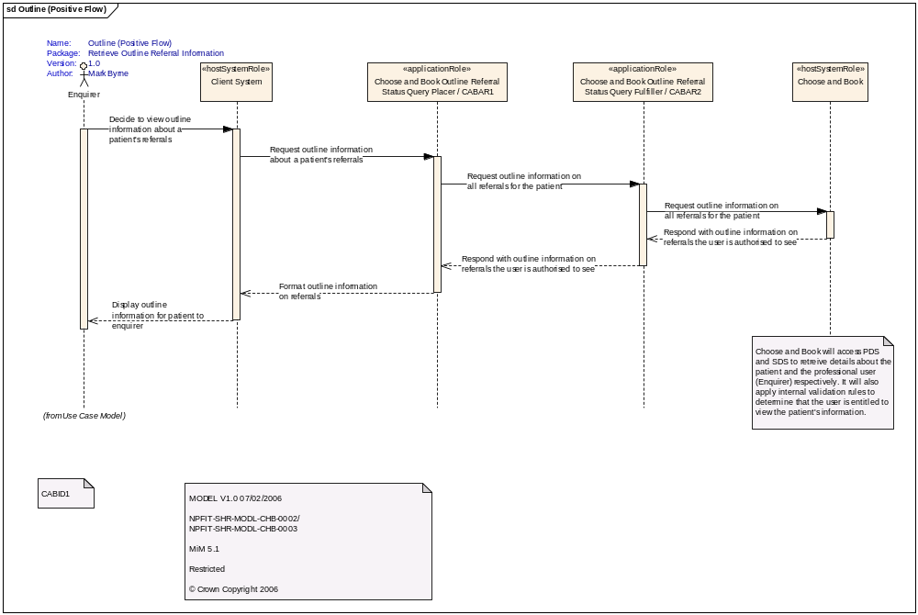
Figure 1: Retrieve Outline Referral Information.

Interaction: Retrieve Outline Referral Information (Error Flow)

Interaction Name | Retrieve Outline Referral Information
Identifier | CABID2
Controlling Use Case | Retrieve Outline Referral Information (CAB5)
Summary Description:
An NHS number is supplied by the calling application, along with a code uniquely identifying the enquirer. It is possible for this interaction to generate an error:
- Enquirer could not be found (unique identifier invalid).
- Enquirer is not acting in a role that is authorised to request information about referrals.
- Enquirer is not entitled to see this patient’s referrals.
- Patient could not be found (NHS Number invalid).
- Patient is stop-noted as I, S or Y. (See [12] for further information on stop note values)
- Internal error in Choose and Book.
Preconditions | Enquirer has already searched for and uniquely identified the patient on PDS.  Patient has an NHS number.
Triggering Event | Enquirer performs an action in the client system that triggers the client system to request outline referral information for a patient from Choose and Book.
Triggering Event Type | Interaction
Subject Class | N/A
Interaction Unit(s) involved | - Request outline information on all referrals for the patient  - Respond with error
Sequence Diagram | See Figure 2.
Interaction Description:
Enquirer
- Decides to review referrals for patient and Initiates interaction with client system.
- Review error returned.
Client System (Host System Role)
- Receive request from enquirer and determine that this needs to be passed to Choose and Book Outline Referral Request Placer.
- Display error to enquirer.
Choose and Book Outline Referral Request Placer (Application Role)
- Receive request from Client System to request referral information. Format and send request for this information to Choose and Book Outline Referral Request Fulfiller.
- Respond with error received from Choose and Book Outline Referral Fulfiller.
Choose and Book Outline Referral Request Fulfiller (Application Role)
- Receive request from Outline Referral Request Placer and forward this to Choose and Book.
- Respond with error received from Choose and Book to Outline Referral Request Placer.
Choose and Book (Host System Role)
- Receive request from Outline Referral Request Fulfiller for patient referral information. Determines if enquirer is entitled to see this information and what information can be displayed to the enquirer.
- Determine that an error response is appropriate and respond with error.
Notes:
- This is a synchronous interaction.
- The processing described in the Choose and Book (Host System Role) will involve interactions with PDS and SDS. However the libraries of interactions for these are not yet available. This processing does not affect the nature of the interaction between the Client System and Choose and Book so these interactions are not modelled.
- Some of the error conditions listed are precluded by the pre-conditions, however, Choose and Book will validate this information again.
- If a patient does not have any referrals or has no referrals the enquirer can see, these are not considered error conditions.

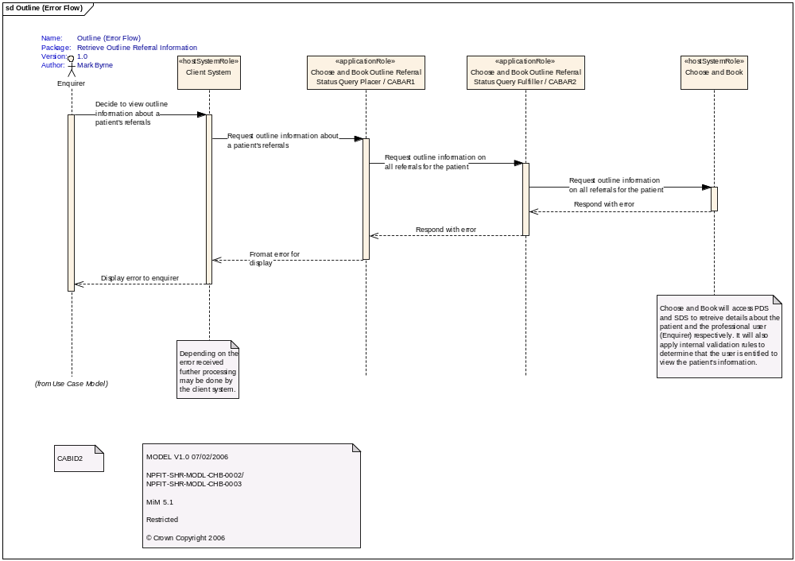
Figure 2: Retrieve Outline Referral Information (Error Flow).

Interaction: Retrieve Details of Specific Referral

Interaction Name | Retrieve Details of Specific Referral
Identifier | CABID3
Controlling Use Case | Retrieve Details of Specific Referral (CAB6)
Summary Description:
An NHS number and unique booking reference number are supplied by the calling application, along with a code uniquely identifying the enquirer. Optionally, the enquirer can request clinical information.
In response details of the referral held in Choose and Book will be returned. Clinical information will be returned if requested.
Preconditions | Enquirer has already searched for and uniquely identified the patient on PDS.  Patient has an NHS number.  Enquirer has a unique reference for a referral (UBRN).
Triggering Event | Enquirer performs an action in the client system that triggers the client system to request detailed referral information for a particular referral from Choose and Book.
Triggering Event Type | Interaction
Subject Class | N/A
Interaction Unit(s) involved | - Request detailed information about a particular referral for a given patient optionally requesting clinical information  - Respond with detailed information about a particular referral for a given patient including clinical information if requested
Sequence Diagram | See Figure 3.
Interaction Description:
Enquirer
- Decides to review detailed referral information for a given referral and initiates interaction with client system.
- Review referral information.
Client System (Host System Role)
- Receive request from enquirer and determine that this needs to be passed externally.
- Format information for display to enquirer.
Choose and Book Detail Referral Request Placer (Application Role)
- Receive request from Client system for detailed referral information. Format and send request for this information to Choose and Book Detail Referral Request Fulfiller.
- Receive referral information from Choose and Book Detail Referral Request Fulfiller.
Choose and Book Detail Referral Request Fulfiller (Application Role)
- Receive request from Choose and Book Detail Referral Request Placer and forward this to Choose and Book.
- Format referral information received into appropriate communication back to Choose and Book Detail Referral Request Placer.
Choose and Book (Host System Role)
- Receive request from Choose and Book Detail Referral Request Fulfiller for patient referral information. Determines if enquirer is entitled to see this information and what information can be displayed to the enquirer.
- Collate information to be returned and send to Choose and Book Detail Referral Request Fulfiller.
Notes:
- This is a synchronous interaction.
- The processing described in the Choose and Book (Host System Role) will involve interactions with PDS and SDS. However the libraries of interactions for these are not yet available. This processing does not affect the nature of the interaction between the Client System and Choose and Book so these interactions are not modelled.
- Error conditions are dealt with in a separate interaction (section 2.2.4).

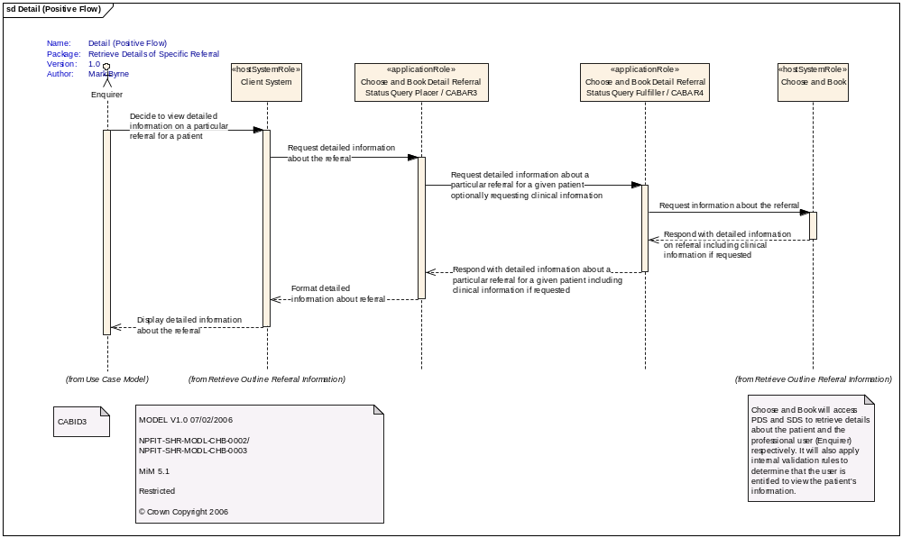
Figure 3: Retrieve Detail Referral Information.

Interaction: Retrieve Detail Referral Information (Error Flow)

Interaction Name | Retrieve Outline Referral Information
Identifier | CABID4
Controlling Use Case | Retrieve Outline Referral Information (CAB6)
Summary Description:
An NHS number is supplied by the calling application, along with a code uniquely identifying the enquirer. It is possible for this interaction to generate an error:
- Enquirer could not be found (unique identifier invalid).
- Enquirer is not acting in a role that is authorised to request information about referrals.
- Enquirer is not entitled to see this patient’s referrals.
- Patient could not be found (NHS Number invalid).
- Patient is stop-noted as I, S or Y.
- Internal error in Choose and Book.
- Enquirer does not have reason to request information about the UBRN.
- UBRN does not exist
- NHS number and UBRN are for different patients.
- Enquirer has requested clinical information and is not authorised to do so.
- Detail of this UBRN is no longer available.
Preconditions | Enquirer has already searched for and uniquely identified the patient on PDS.  Patient has an NHS number.  Enquirer has a unique reference for a referral (UBRN).
Triggering Event | Enquirer performs an action in the client system that triggers the client system to request detailed referral information for a particular referral from Choose and Book.
Triggering Event Type | Interaction
Subject Class | N/A
Interaction Unit(s) involved | - Request detailed information about a particular referral for a given patient optionally requesting clinical information  - Respond with error
Sequence Diagram | See Figure 4.
Interaction Description:
Enquirer
- Decides to review detailed referral information for a given referral and initiates interaction with client system.
- Review error returned.
Client System (Host System Role)
- Receive request from enquirer and determine that this needs to be passed to Choose and Book Detail Referral Request Placer.
- Display error to enquirer.
Choose and Book Detail Referral Request Placer (Application Role)
- Receive request from Client system for detailed referral information. Format and send request for this information to Choose and Book Detail Referral Request Placer.
- Respond with error received from Choose and Book Detail Referral Request Fulfiller.
Choose and Book Detail Referral Request Fulfiller (Application Role)
- Receive request from Choose and Book Detail Referral Request Placer and forward this to Choose and Book.
- Respond to Choose and Book Detail Referral Request Placer with error received from Choose and Book.
Choose and Book (Host System Role)
- Receive request from Choose and Book Detail Referral Request Fulfiller for patient referral information. Determines if enquirer is entitled to see this information and what information can be displayed to the enquirer.
- Determine that an error response is appropriate and respond with error to Choose and Book Detail Referral Request Fulfiller.
Notes:
- This is a synchronous interaction.
- The processing described in the Choose and Book (Host System Role) will involve interactions with PDS and SDS. However the libraries of interactions for these are not yet available. This processing does not affect the nature of the interaction between the Client System and Choose and Book so these interactions are not modelled.
- Some of the error conditions listed are precluded by the pre-conditions, however, Choose and Book will validate this information again.

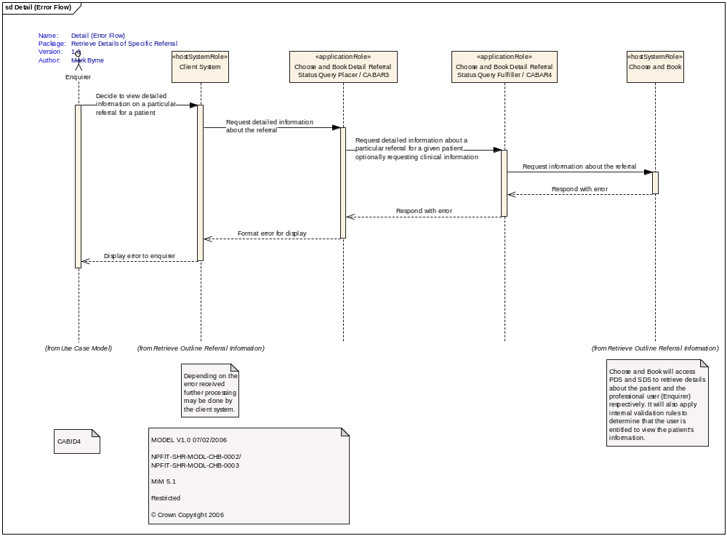
Figure 4: Retrieve Detail Referral Information (Error Flow).

